Shape Type of Coil
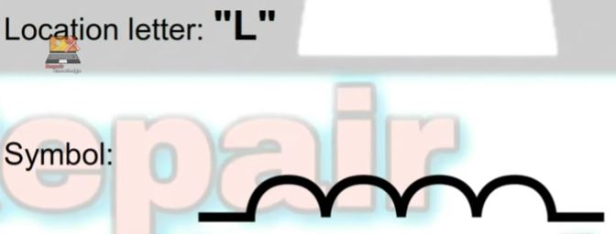

- Solid coil- normal solid coil, solid pack coil
- SMD coil- normal SMD Coil, SMD Pack Coil
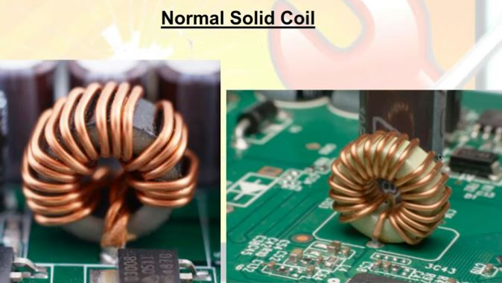

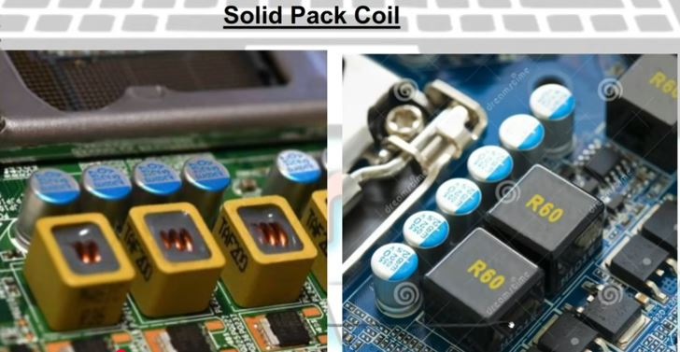

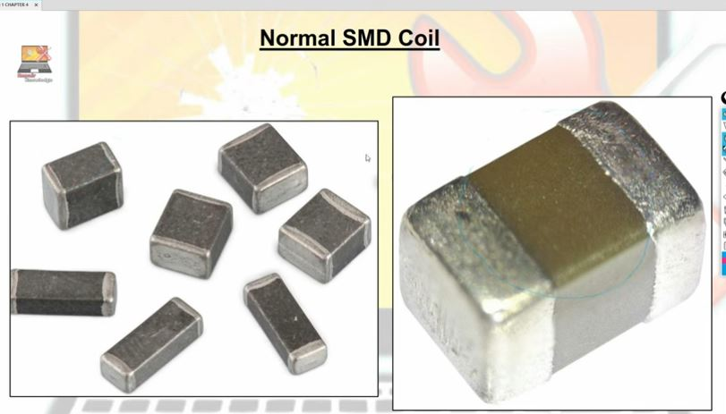
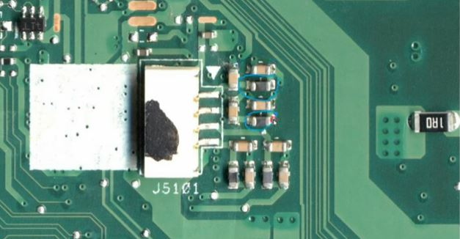
Grey Yellow
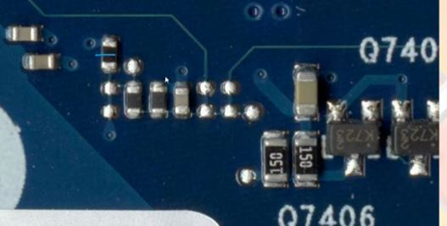
Grey Yellow(C) Black(R)

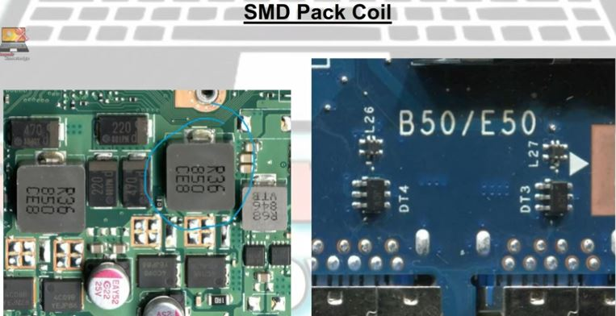

Good condition:- 00 in doide mode.
Bad condition : value 50 ya 100 ke upar ja raha hai

